Question #7:

#include<iostream>

#include<string>

using namespace std;

int main()

{

string str1 = "WARM";//taking two string //

string str2 = "COLD";

string temp = str1;//swapping these variables//

str1 = str2;

str2 = temp;

cout << str1 << endl;//displaying//

cout << str2 << endl;

system("pause");

return 0;

}

Output:

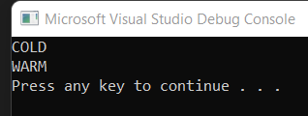

2nd Method :

#include<iostream>

#include<string>

using namespace std;

int main()

{

string str1 = "WARM";//taking two string //

string str2 = "COLD";

str1.swap(str2);

cout << str1 << endl;//displaying//

cout << str2 << endl;

system("pause");

return 0;

}

Output:



Task #8:

#include<iostream>

using namespace std;

int strlen(char str)//Making function//

{

int len = 0;

while (str != '\0')

{

len++;//incrementing//

str++;

}

return len;//returning Length//

}

void reverse(char str, int len) //Making void Function for string length//

{

for (int i = 0; i<len / 2; i++)

{

char temp = str[i];

str[i] = str[len - i - 1];

str[len - i - 1] = temp;

}

}

int main() {

cout << "Enter the Characters to reverse ";

char str[100]; //array of size 100//

cin.getline(str, 100);//Taking input//

reverse(str, strlen(str));//Function for reverse string//

cout << str << endl;//Displaying characters//

getchar();

system("pause");

return 0;

}

Output:

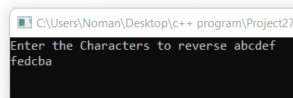

Task #10

#include <iostream>

#include <string.h>

using namespace std;

int main()

{

char string[100]; // declaring variables..

int i, vow = 0;

cout << "Enter the string : ";

cin >> string; // taking string from user.

//Initializing for loop.

for (i = 0; string[i] !='\0'; i++) // iterate loop

{

//Counting the vowels in a string.

if (string[i] == 'a' || string[i] == 'e' || string[i] == 'i' || string[i] == 'o' || string[i] == 'u' || string[i] == 'A' || string[i] == 'E' || string[i] == 'I' || string[i] == 'O' || string[i] == 'U')

{

vow++;

}

}

//Printing number of vowels.

cout << "Total number of vowels in a gievn string are = " << vow;

system("pause");

return 0;

}

Output:

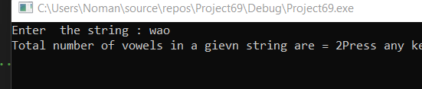

Task #9:

#include <iostream>

using namespace std;

bool isPalindrome(string str)//making bool function//

{

int low = 0;//Intializing variables //

int high = str.length() - 1;//subtraction from string length//

while (low < high)

{

// if a mismatch happens

if (str[low] != str[high])

{

return false;

}

low++;

high--;

}

return true;

}

int main()

{

string str = "abcba";//Taking a string//

if (isPalindrome(str))//condition for string//

cout << "Palindrome" << endl;

}

else {

cout << "Not Palindrome" << endl;

}

system("pause");

return 0;

}

Output:

